Practical Test – Ball Battle

# Game UI

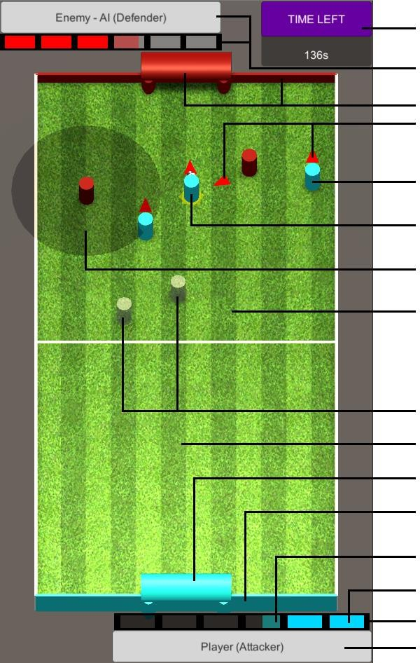Time remaining in the Match

Enemy Info & Energy Enemy Gate & Fence

Direction indicator for “Moving” soldiers

Attacker in Blue – Player flag color

Attacker - highlight when holding the Ball Range detection of the Defender in Red

– Enemy flag color

Enemy Land Field

Inactivated Soldiers (both factions) Player Land Field

Player Gate Player Fence

Energy is filling overtime

Energy is filled into Energy Point Player Energy Bar

Player Info

# Gameplay

## The Battle Field:

The board is split into 2 land fields of 2 fractions: Player and Enemy.

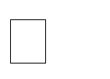

Player and Enemy will have 2 different flag color, using for colorize their Gate, Fence and Soldier. The Ball is generated randomly in the Land Field whose is attacking.

## Matches:

This is a turn-base Game, switch the attack/defense position each match

* + In 1st match, Player will attack the Enemy
  + Then 2nd match, Player will defense the Enemy’s attack
  + ...

There will be time limit for each match

## Energy Bar:

Empty when the game start



Regenerated overtime with defined rate (1) Highlight the real Energy points once it’s filled.

## The Control:

Tap on the Land Fields to spawn the corresponding Soldier with color faction flag

* + Attack land will spawn Attacker
  + Defense land will spawn Defender

## Soldier Behavior:

1. **Attacker:**

Spawn cost energy point (2) and being inactivated for a period of time. (3) When activated:



* + Chase the Bomb until it’s hold by an Attacker.
  + If holding the Ball,

Go straight into the opponent’s Gate at slower speed (6) Can be caught by the opponent’s Defenders



If caught, pass the Ball to nearest active Attacker at a speed (7) and become Inactivated for a period of time (4)

* + If no Ball to chase or hold, go straight into the opponent Land Field

Being destroy when reaching the opponent’s Fence at normal speed (5) Cannot be caught, go though all soldiers (include the attackers).



When inactivated:

* + Greyscale until reactivated
  + Stop moving and let any soldier go thourgh.

## Defender:

* Spawn cost energy point (2) and being inactivated for a period of time. (3)
* When activated:
  + Standby after activated
  + Chasing when the attacker with Ball reach the Detection circle: Lock target to that attacker, and chasing it at a speed (5)



If caught the target, become Inactivated for a period of time (4)

* When inactivated:
  + Greyscale until reactivated
  + Moving back to its origin position at faster speed (8)
  + Let any soldier go through
* The Detection circle is only available at Standby state (9)

## Please Note:

* There will be no need to write an AI to play Enemy part.
* The game will be played by 2 people in theory.

# Parameters

|  |  |  |  |
| --- | --- | --- | --- |
|  | **Match per Game** | **Time limit** | **Energy bar** |
| **Game** | 5 | 140 sec | 6 points |

|  |  |  |
| --- | --- | --- |
| **Soldier** | **Attacker** | **Defender** |
| **(1) Energy regeneration** | 0.5 per sec | 0.5 per sec |
| **(2) Energy cost** | 2 points | 3 points |
| **(3) Spawn Time** | 0.5 sec | 0.5 sec |
| **(4) Reactivate Time** | 2.5 sec | 4 sec |
| **(5) Normal Speed** | 1.5 * Time.deltatime | 1.0 * Time.deltatime |
| **(6) Carrying Speed** | 0.75 * Time.deltatime |  |
| **(7) Ball Speed** | 1.5 * Time.deltatime | |
| **(8) Return Speed** |  | 2 * Time.deltatime |
| **(9) Detection range** | 35% width of the battle field | |

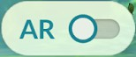**AR Mode**

Add button to switch the gameplay into AR mode Detection a surface and start the game above that surface. Keep the game at that surface only.



Able to play the game without controlling issues.

*Please follow the attached reference document for more details.*

# Game Ends

Result of the match:

* The Ball has been reach the opponent’s Gate -> The Attacker **WIN**
* When timeout, the Ball is not reach the opponent’s Gate -> The Match is **DRAW**
* When the Attacker is caught but no other attacker is available to pass to Ball to -> The Defender

## WIN

After 5 matches:

* Game Over if the player has less **WIN** than the enemy.
* The player will be the Winner if have more **WIN** than the enemy.
* If the **WIN** check is equal, there will be a Penalty game for the player.

# Penalty Game: The Maze Runner

Using the same map as before.

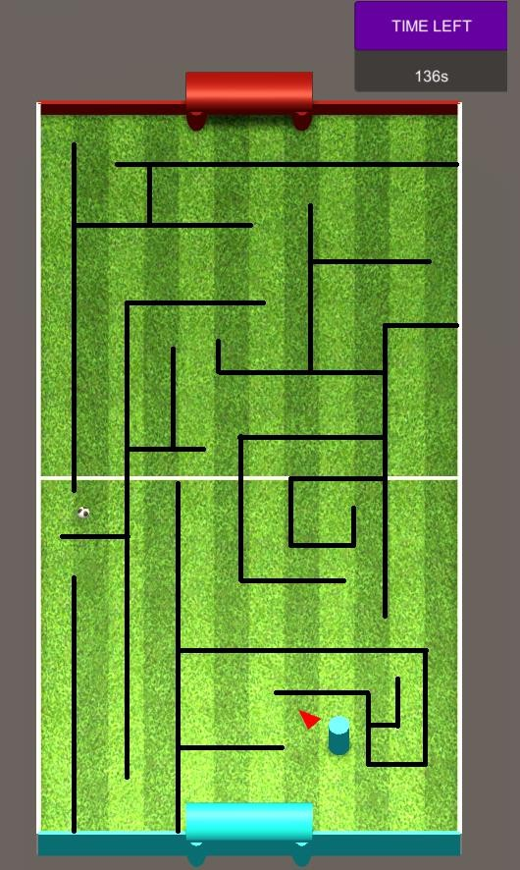

(Example image only)

There will be only one Attacker avaible, start at the Player’s Gate Generate a Maze inside the map with only one way to go from

the Player’s Gate to Enemy’s Gate.

The Ball will be generated at somewhere that can be reached inside the Maze.

In the limit time, if the player can get the Ball and reach the Enemy’s Gate -> The Player will be the **Winner**, else **GameOver**.

# Requirements

## Completion of each task has the corresponding points Need to complete the tasks with priorities:



* **1** – Must have
* **2** – Must have
* **3** – Should be have
* **4** – Great to have

|  |  |  |  |
| --- | --- | --- | --- |
| **Section** | **Prio** | **Features** | **Points** |
| **Gameplay BASIC 1** | **1** | 3D Unity Project | 5 |
| **1** | Graphic: Battle Field, Ball, Soldiers, Timebox, EnergyBars... Control: Tap on Battle Fields  Camera: Orthographic |
| **1** | Resolve Game End | 2 |
| **1** | Indicators   * Direction of Soldiers * Highlight of Attacker holding the Ball | 1 |
| **1** | Solve the collision between the attackers and defenders | 1 |
| **2** | Animation when the Defender caught the Attacker (for both) | 1.5 |
| **2** | Animation for the Defender Vision |
| **2** | Animation when the Soldier is Spawn |
| **2** | Animation when the Attacker is destroyed at opponent’s Fence |
| **AR Mode BASIC 2** | **1** | Able to detect surface and display the game on it Able to switch between normal and AR mode Complete *basic requirements* defined on  **Unity_Test_AR_Ref.pdf** | 1 |
| **Pernalty Map**  **ADVANCE** | **2** | Generate the Maze successfully  The Ball is placed randomly at place that can be get | 1.5 |

|  |  |  |  |
| --- | --- | --- | --- |
|  |  | The Maze can be solved (has way out) |  |
| **Gameplay BONUS 1** | **3** | Using Model to replace to Ball, Attackers and Defenders...  (Reference: https://[www.mixamo.com/)](http://www.mixamo.com/)) | 1 -> 4  points |
| **3** | Particles effects for:   * Gate/Fence * Soldier in countdown to be reactivated * The Defender Detection Circle |
| **3** | Menu system   * Main Menu * In Game Menu * Win-Lose Screens |
| **4** | Extra gameplay:  Rush Time: for last 15s   * The energy regenerate faster * Defender is now reactivated when back to it position * The Attacker that carry the Ball will not move slower |
| **4** | Sound BGM/SFX  Use cinemachine to make Intro |
| **AR Mode BONUS 2** | **3** | Has Pinch zoom and Swipes horizontally  Display Shadow for Game board Using Universal Render Pipeline |

**Submit format:** Link Github (**WITHOUT ANY WORD MENTION ABOUT GAMELOFT**)

**Platform:**

* Unity Windows (*.**EXE**)
* Unity Mobile (**iOS/Android**)